

**CC0007 Group Proposal (3)**

*Combating Voyeurism in Singapore*

| **Cluster** | C |
| --- | --- |
| **Group** | 30 |
| **Group Members** | Wang Jie Rui, Jerome  Lim Dong Wan  Ryan Tan Kai Hong  Ng Hui Yi  Le Minh Anh Ngoc |
| **Cluster Instructor** | Prof Low Chin Wui, Marc |
| **Word Count** | 599 (excluding cover page, footnotes, figure captions, in-text citations, and references) |

# **Introduction**

Voyeurism - the “perverse behaviour involving deliberate and wilful intrusion of someone’s privacy” (Singapore Legal Advice, 2021) - has become increasingly prevalent in modern societies like Singapore (Figure 1) (Sun, 2022). With the proliferation of technological devices in our lives, coupled with the miniaturization of cameras[1], it has become extremely easy for bad actors[2] to harness technology for illicit activities[3], with others none the wiser.

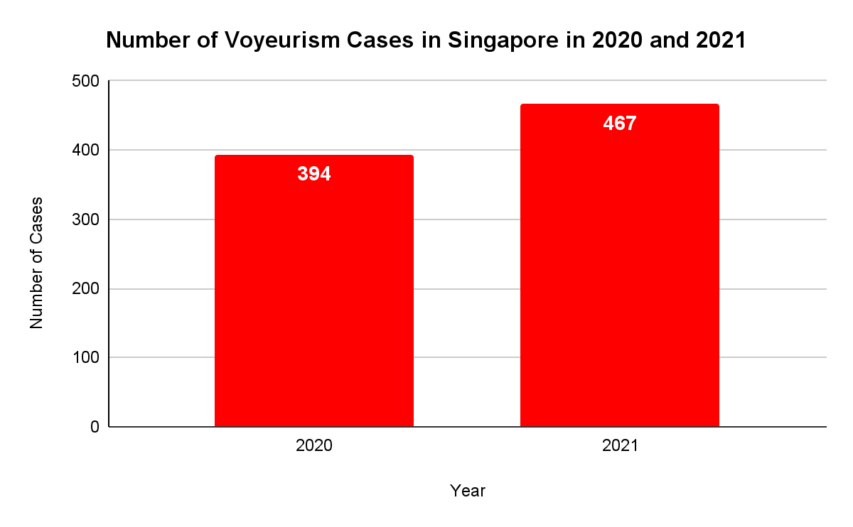

*Figure 1: Increasing Prevalence of Voyeurism in Singapore (Sun, 2022)*

In light of this phenomenon, Parliament passed a bill[4] in September 2021 to legislate stiffer penalties[5] for sex crimes like voyeurism (Sun, 2022). This resulted in a slight dip in cases (Figure 2) (SPF, 2022), signifying that the government strongly desires to clamp down on this prevalent issue.

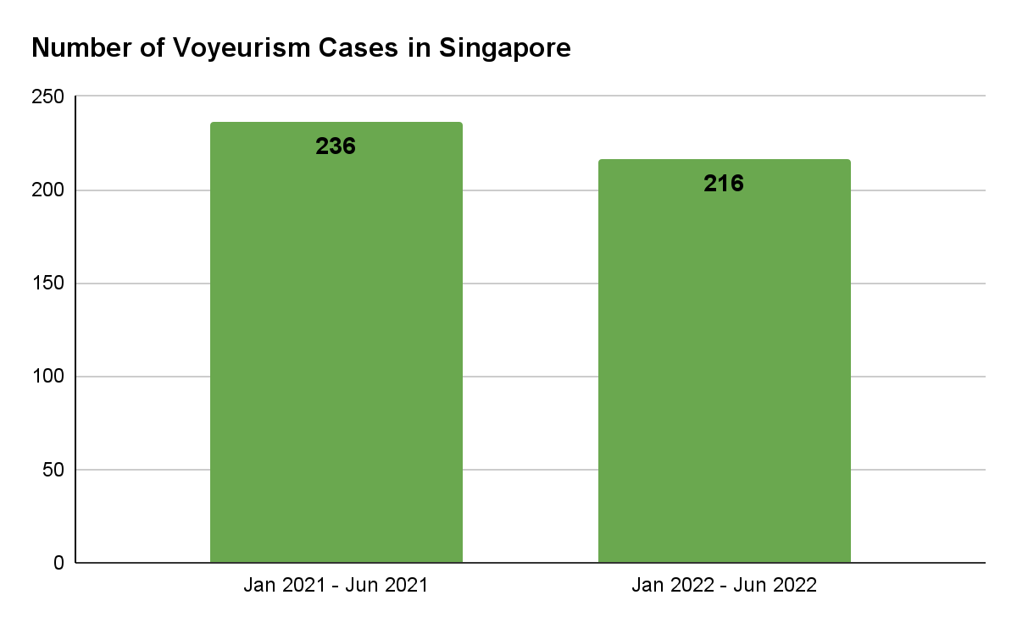

*Figure 2: Slight Improvement in Voyeurism Cases in Singapore (SPF, 2022)*

Yet, the introduction of anti-voyeur laws have unsurprisingly done little to stymie the perpetrators’ ill intentions, since there is negligible continuous monitoring and detection of voyeuristic actions[6], given the existence of repeated serial voyeurs in our society today (malaymail, 2022). Left unaddressed, this would engender negative repercussions on society and the psychological well-being of people.

Hence, our proposed solution aims to assist enforcement agencies[7], by harnessing technology[8] for good to address the misuse of technology[9] for regrettable ends.

# **Proposed Innovation**

*SafeSecure* is a Computer-Vision AI that takes CCTV video streams as input, and outputs timestamps and pixel coordinates where high-threat actions are flagged. *SafeSecure* aims to bridge the surveillance gap for voyeuristic actions, by monitoring CCTV footage in real-time and identifying actions that have a high possibility of being voyeuristic in nature, subsequently flagging them out.

# **AI Architecture**

*SafeSecure* will be premised upon 4 models (Figure 3) - OpenPose (Cao et al., 2019), Yolov7 (Wang et. al., 2022), Seq2Class Transformer (Liu, 2021) and DeepSort (Wojke, 2017).

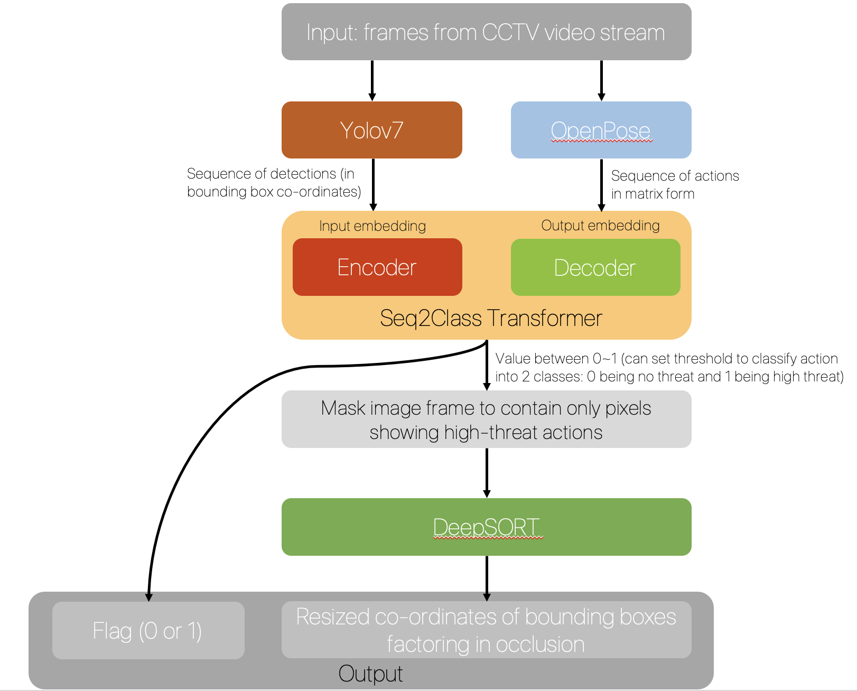

*Figure 3: Overall Architecture*

The input frames from the CCTV video stream will first be delivered into OpenPose (Figure 4) to get the sequence of actions in matrix form,

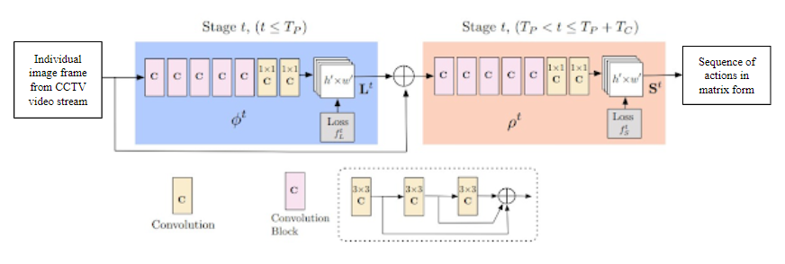

*Figure 4: OpenPose Network Architecture adapted from (Anubhav, 2022)*

while performing object detection using the Yolov7 Single Shot Detector (Figure 5). 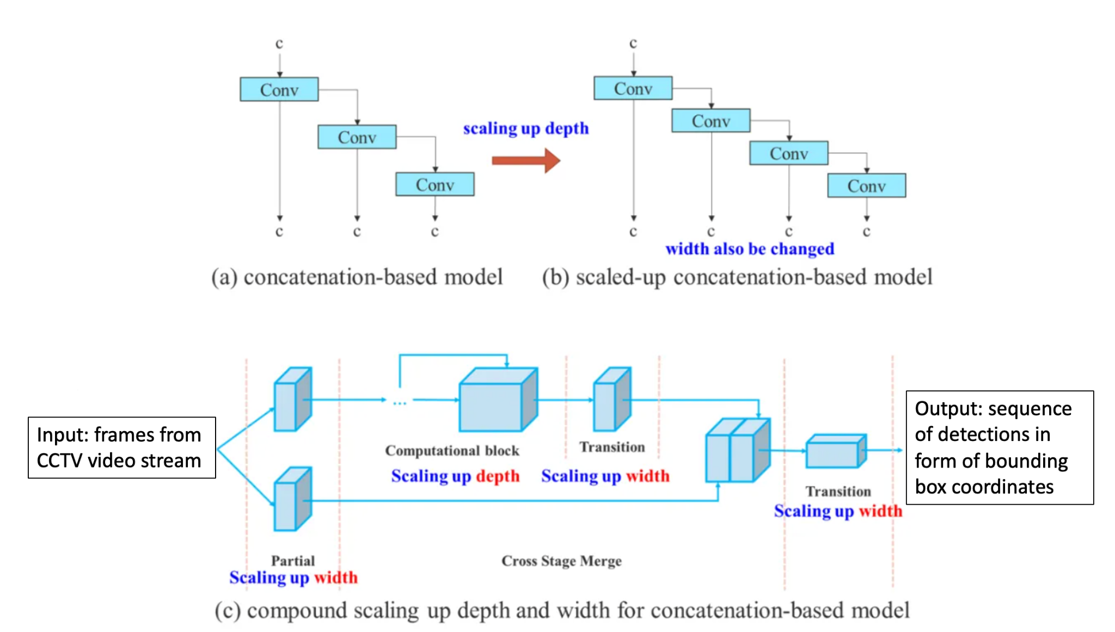

*Figure 5: Yolov7 Network Architecture adapted from (Gaudenz, 2022)*

Next, the detections performed in the Yolov7 will be contextualized in Visual Grammar (Nguyen et. al., 2021) form via the attention mechanism in the Seq2Class Transformer (Figure 6).

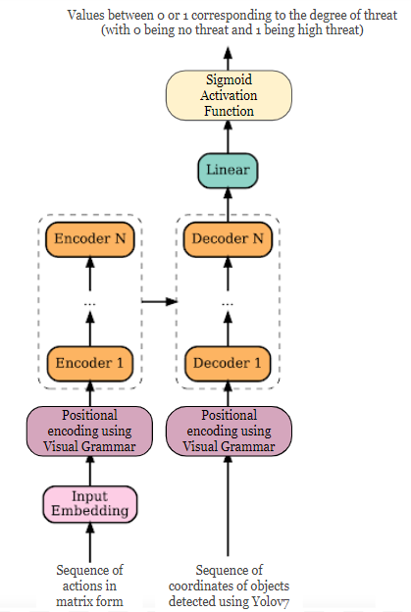

*Figure 6: Seq2Class Network Architecture adapted from (Liu, 2021)*

Finally, the Transformer will output binary classes of 0 and 1, corresponding to non-threat and threat actions, which will determine which actions and entities (humans) to track using the DeepSort algorithm (Figure 7).

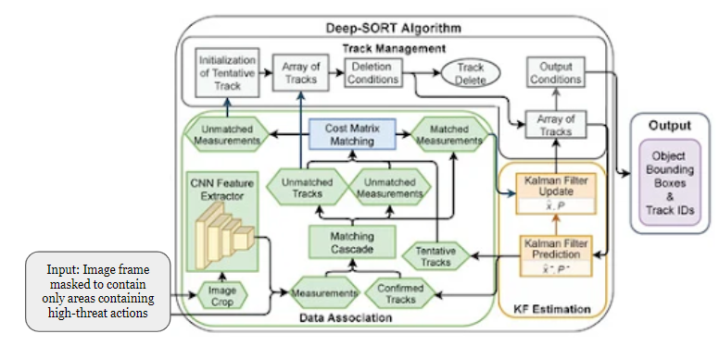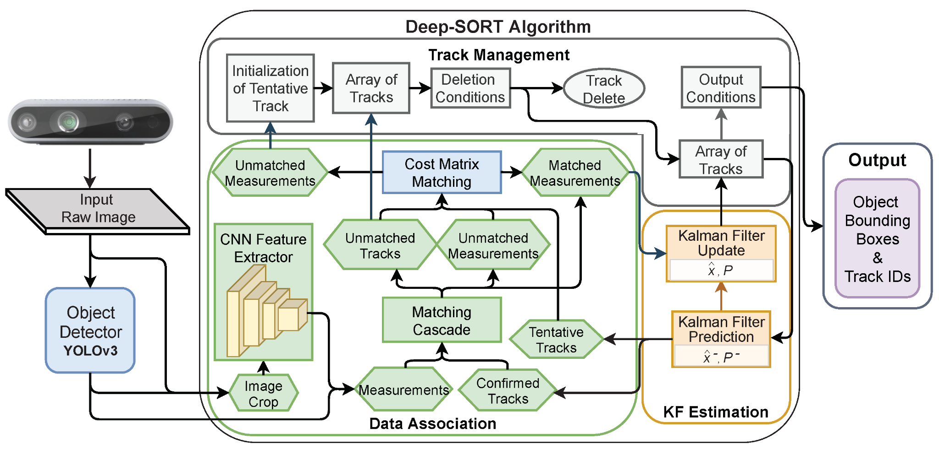

*Figure 7: DeepSort Algorithm Pseudocode adapted from (Pereira et. al., 2022)*

# **Features**

| **Feature** | **Benefit** | **Feasibility** |
| --- | --- | --- |
| **Ability to Analyse Threats and Identify Suspects** | Serves as a deterrence[10] for voyeurism. If the act is still committed, the offender will not escape unpunished. | In a similar light, police cameras have been used to solve over 5,000 criminal cases since 2012 (CNA, 2021).  Granted, there may be blind spots, but these should be rare[11].  SPF projects 200,000 more police cameras by 2030 (CNA, 2021), enabling wider coverage by *SafeSecure.* |
| **Enhanced Policing Capabilities** | 1. Lead time to arrest will be significantly decreased[12]. 2. Resources can be more effectively deployed (on a need basis rather than as part of OM ops[13]), since voyeuristic actions will be flagged in real-time, thereby freeing up manpower for more pertinent matters. |
| **Sensitivity to Body Movement** | Able to detect even the slightest body movements[14], which can be crucial in determining and understanding the suspect’s motives. | Attention-based mechanism of the Transformer network is able to detect minute changes as it draws global dependencies[15] (Vaswani et. al., 2017). |

# 

# **Considerations**

***Dearth of Training Data***

To accurately detect voyeurism in real-time, the model must be trained with considerable annotated data of past incidents. Such data may currently be insufficient, thereby necessitating sourcing or generating new datasets, which would be both timely and costly. However, we can mitigate this by Transfer Learning[16] (Figure 8).

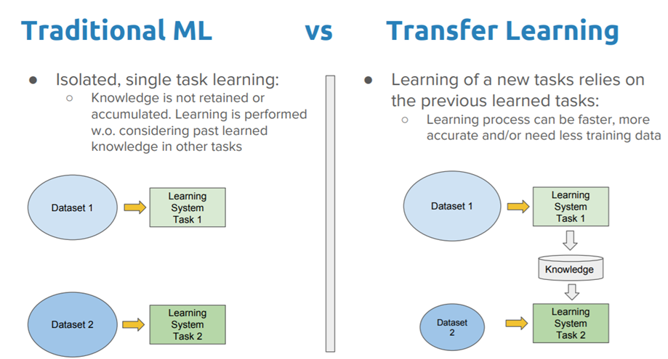

*Figure 8: Traditional Machine Learning vs. Transfer Learning (Pragati, 2022)*

***Expensive process***

An inherent limitation of AI systems is the costly process of development and implementation. Although Transfer Learning can help reduce costs, the resources needed for data collection, training, and testing are still considerably significant. However, the cost of implementing *SafeSecure* is justified as it provides continuous monitoring and detection (from none before), which will deter voyeurism.

**References**

**Papers on Domain Knowledge (Voyeurism)**

* Chua, K. H. (n.d.). *Tech in Asia - connecting Asia's startup ecosystem*. Retrieved November 8, 2022, from <https://www.techinasia.com/ai-facial-recognition-revolutionizing-physical-security-asia>
* CNA. (2021, October 10). *Caught on camera: How 90,000 police cameras across Singapore help solve crimes.* Retrieved November 6, 2022, from <https://www.channelnewsasia.com/singapore/90000-police-cameras-surveillance-crimes-2230176>
* Ganapathy, A. (2020, December 1). *The Crime of Voyeurism.* IRB Law LLP. Retrieved November 5, 2022, from

<https://irblaw.com.sg/learning-centre/voyeurism/>

* James, G. (n.d.). *Voyeurism in Singapore: Perspectives of a criminal defence lawyer*. International Bar Association. Retrieved November 5, 2022, from <https://www.ibanet.org/article/C2618FBC-D2BF-4E92-AF3C-71304062813D>
* MalayMail. (2022, October 20). *In Singapore, serial voyeur jailed again for taking upskirt photos and videos of women riding escalators.* Retrieved November 5, 2022, from

<https://www.malaymail.com/news/singapore/2022/10/20/in-singapore-serial-voyeur-jailed-again-for-taking-upskirt-photos-and-videos-of-women-riding-escalators/34643>

* Singapore Legal Advice. (2022, March 1). *Crime of Voyeurism in Singapore.* Retrieved November 5, 2022, from <https://singaporelegaladvice.com/law-articles/crime-voyeurism-singapore-penalties-defences/>
* SPF. (2022). *Police News Release - Mid-Year Crime Statistics 2022*. Retrieved November 6, 2022, from <https://www.police.gov.sg/-/media/90E8A6D32BBE4E838025817C160E40CA.ashx>
* Sun, D. (2022, February 28). *Sex offenders to be dealt with more severely from March 1 under amended laws*. The Straits Times. Retrieved November 5, 2022, from

<https://www.straitstimes.com/singapore/sex-offenders-to-be-dealt-with-more-severely-from-march-1-under-amended-laws>

**AI Papers**

* Baheti, P. (2022, October 21). *A Newbie-Friendly Guide to Transfer Learning*. V7. Retrieved November 5, 2022, from <https://www.v7labs.com/blog/transfer-learning-guide>
* Boesch, G. (2022, September 21). *YOLOv7: The Most Powerful Object Detection Algorithm (2022 Guide)*. viso.ai. Retrieved November 5, 2022, from <https://viso.ai/deep-learning/yolov7-guide/>
* Cao, Z., Hidalgo, G., Simon, T., Wei, S.E., Sheikh Y. (2019, May 30). *OpenPose: Realtime Multi-Person 2D Pose Estimation using Part Affinity Fields*. Retrieved November 5, 2022, from

<https://arxiv.org/pdf/1812.08008.pdf>

* Liu, X. (2021). *A Spam Transformer Model for SMS Spam Detection.* Retrieved November 5, 2022, from <https://ruor.uottawa.ca/bitstream/10393/42057/3/Liu_Xiaoxu_2021_thesis.pdf>
* Nguyen, X.-B., Bui, D. T., Duong, C. N., Bui, T. D., & Luu, K. (2021). *Clusformer: A transformer based clustering approach to unsupervised large-scale face and visual landmark recognition.* 2021 IEEE/CVF Conference on Computer Vision and Pattern Recognition (CVPR). Retrieved November 5, 2022, from

<https://doi.org/10.1109/cvpr46437.2021.01070>

* Pereira, R., Carvalho, G., Garrote, L., Nunes, U.J. (2022, January 22). *Sort and Deep-SORT Based Multi-Object Tracking for Mobile Robotics: Evaluation with New Data Association Metrics*. MDPI. Retrieved November 8, 2022, from <https://www.mdpi.com/2076-3417/12/3/1319/htm>
* Tewari, A. (2022, February 11). *OpenPose Systems*. OpenGenus IQ: Computing Expertise & Legacy. Retrieved November 5, 2022, from <https://iq.opengenus.org/openpose-systems/>
* Wojke, N., Bewley, A., Paulus, D. (2017, March 21). *Simple Online and Realtime Tracking with a Deep Association Metric.* Retrieved November 5, 2022, from

<https://arxiv.org/pdf/1703.07402.pdf>

1. Such as on our smartphones
2. Colloquially known by Singaporeans as “Peeping Toms”
3. i.e. recording others surreptitiously.
4. The bill was to introduce The Criminal Law (Miscellaneous Amendments) Act 2021, which took effect in March 2022.
5. Some of the amended penalties covered include: 3-year maximum jail time for molesters, up from 2 years, and maximum penalty for other sexual offences (ie. voyeurism) to be on par with existing maximum sentences for offences involving minors.
6. This led to many partaking in that act thinking they can walk away scot-free.
7. i.e. Singapore Police Force, Certis Cisco
8. Artificial Intelligence (AI)
9. Smartphones, small recording devices
10. The threat of getting caught (due to continuous detection)
11. Given existing coverage
12. Given the AI performs continuous detection in real-time
13. Outrage of Modesty Operations (patrols)
14. Of the Suspect
15. Attention-based transformer performs well even when dealing with noisy or “hard” samples (commonly mis-inferred samples) that traditional neural networks face problems with
16. Transfer Learning is a machine learning method where a pre-trained model is reused as the starting point for a model on a new task. By doing so, we can achieve much higher accuracy despite having only a smaller number of annotated samples to train on.